The EPA Administrator, Gina McCarthy, signed the following notice on 9/29/2015, and EPA is submitting it for publication in the Federal Register (FR). While we have taken steps to ensure the accuracy of this Internet version of the rule, it is not the official version of the rule for purposes of compliance. Please refer to the official version in a forthcoming FR publication, which will appear on the Government Printing Office's FDSys website (http://gpo.gov/fdsys/search/home.action) and on Regulations.gov (http://www.regulations.gov) in Docket No. EPA- HQ-OAR-2010-0682. Once the official version of this document is published in the FR, this version will be removed from the Internet and replaced with a link to the official version

Method 325A—Volatile Organic Compounds from Fugitive and Area Sources:
Sampler Deployment and VOC Sample Collection

  - Scope and Application

  - This method describes collection of volatile organic compounds (VOCs) at or inside a facility property boundary or from fugitive and area emission sources using passive (diffusive) tube samplers (PS). The concentration of airborne VOCs at or near these potential fugitive- or area-emission sources may be determined using this method in combination with Method 325B. Companion Method 325B (Sampler Preparation and Analysis) describes preparation of sampling tubes, shipment and storage of exposed sampling tubes, and analysis of sampling tubes collected using either this passive sampling procedure or alternative active (pumped) sampling methods.
  - This method may be used to determine the average concentration of the select VOCs using the corresponding uptake rates listed in Method 325B, Table 12.1. Additional compounds or

alternative sorbents must be evaluated as described in Addendum A of Method 325B or by one of the following national/ international standard methods: ISO 16017-2:2003(E), ASTM D6196-
03 (Reapproved 2009), or BS EN 14662-4:2005 (all incorporated by reference—see §63.14), or reported in the peer-reviewed open literature.
  - Methods 325A and 325B are valid for the measurement of benzene. Supporting literature (References 1-8) indicates that benzene can be measured by flame ionization detection or mass spectrometry over a concentration range of approximately 0.5 micrograms per cubic meter (µg/m3) to at least 500 µg/m3 when industry standard (3.5 inch long x 0.25 inch outside diameter (o.d.) x 5 mm inner diameter (i.d.)) inert-coated stainless steel sorbent tubes packed with CarbographTM 1 TD, CarbopackTM B, or CarbopackTM X or equivalent are used and when samples are accumulated over a period of 14 days.
  - This method may be applied to screening average airborne VOC concentrations at facility property boundaries or monitoring perimeters over an extended period of time using multiple sampling periods (e.g., 26 x 14-day sampling periods).
The duration of each sampling period is normally 14 days.

  - This method requires the collection of local meteorological data (wind speed and direction, temperature, and barometric pressure). Although local meteorology is a component

of this method, non-regulatory applications of this method may use regional meteorological data. Such applications risk that the results may not identify the precise source of the emissions.
  - Summary of the Method

  - Principle of the Method. The diffusive passive sampler

collects VOC from air for a measured time period at a rate that is proportional to the concentration of vapor in the air at that location.
    - This method describes the deployment of prepared passive samplers, including determination of the number of passive samplers needed for each survey and placement of samplers along or inside the facility property boundary depending on the size and shape of the site or linear length of the boundary.
    - The rate of sampling is specific to each compound and depends on the diffusion constants of that VOC and the sampler dimensions/characteristics as determined by prior calibration in a standard atmosphere (Reference 1).
    - The gaseous VOC target compounds migrate through a constant diffusion barrier (e.g., an air gap of fixed
dimensions) at the sampling end of the diffusion sampling tube and adsorb onto the sorbent.
    - Heat and a flow of inert carrier gas are then used

to extract (desorb) the retained VOCs back from the sampling end of the tube and transport/transfer them to a gas chromatograph (GC) equipped with a chromatographic column to separate the VOCs and a detector to determine the quantity of target VOCs.
    - Gaseous or liquid calibration standards loaded onto the sampling ends of clean sorbent tubes must be used to calibrate the analytical equipment.
    - This method requires the use of field blanks to ensure sample integrity associated with shipment, collection, and storage of the passive samples. It also requires the use of field duplicates to validate the sampling process.
    - At the end of each sampling period, the passive samples are collected, sealed, and shipped to a laboratory for analysis of target VOCs by thermal desorption gas chromatography, as described in Method 325B.
  - Application of Diffusive Sampling.

    - This method requires deployment of passive sampling tubes on a monitoring perimeter encompassing all known emission sources at a facility and collection of local meteorological data. It may be used to determine average concentration of VOC at a facility’s “fenceline” using time integrated passive sampling (Reference 2).
    - Collecting samples and meteorological data at progressively higher frequencies may be employed to resolve

shorter term concentration fluctuations and wind conditions that could introduce interfering emissions from other sources.
    - This passive sampling method provides a low cost approach to screening of fugitive or area emissions compared to active sampling methods that are based on pumped sorbent tubes or time weighted average canister sampling.
      - Additional passive sampling tubes may be deployed at different distances from the facility property boundary or from the geometric center of the fugitive emission source.
      - Additional meteorological measurements may also be collected as needed to perform preliminary gradient-based assessment of the extent of the pollution plume at ground level and the effect of “background” sources contributing to airborne VOC concentrations at the location.
    - Time-resolved concentration measurements coupled with time-resolved meteorological monitoring may be used to generate data needed for source apportionment procedures and mass flux calculations.
  - Definitions

(See also Section 3.0 of Method 325B.)

  - Fenceline means the property boundary of a facility or

internal monitoring perimeter established in accordance with the requirements in Section 8.2 of this method.
  - Passive sampler (PS) means a specific type of sorbent

tube (defined in this method) that has a fixed dimension air (diffusion) gap at the sampling end and is sealed at the other end.
  - Passive sampling refers to the activity of

quantitatively collecting VOC on sorbent tubes using the process of diffusion.
  - PSi is the annual average for all PS concentration

results from location i.

  - PSi3 is the set of annual average concentration results

for PSi and two sorbent tubes nearest to the PS location i.

  - PSip is the concentration from the sorbent tube at

location i for the test period or episode p.

  - Sampling period is the length of time each passive

sampler is exposed during field monitoring. The sampling period for this method is 14 days.
  - Sorbent tube (Also referred to as tube, PS tube,

adsorbent tube, and sampling tube) is an inert coated stainless steel tube. Standard PS tube dimensions for this method are 3.5- inch (89 mm) long x 0.25-inch (6.4 mm) o.d. with an i.d. of 5 mm, a cross-sectional area of 19.6 mm2 and an air gap of 15 mm. The central portion of the tube is packed with solid adsorbent material contained between 2 x 100-mesh stainless steel gauzes and terminated with a diffusion cap at the sampling end of the tube. These axial passive samplers are installed under a

protective hood during field deployment.

Note: Glass and glass- (or fused silica-) lined stainless steel sorbent tubes (typically 4 mm i.d.) are also available in various lengths to suit different makes of thermal desorption equipment, but these are rarely used for passive sampling because it is more difficult to adequately define the diffusive air gap in glass or glass-line tubing. Such tubes are not recommended for this method.
  - Sampling Interferences

  - General Interferences. Passive tube samplers should be

sited at a distance beyond the influence of possible obstructions such as trees, walls, or buildings at the monitoring site. Complex topography and physical site obstructions, such as bodies of water, hills, buildings, and other structures that may prevent access to a planned PS location must be taken into consideration. You must document and report siting interference with the results of this method.
  - Background Interference. Nearby or upwind sources of

target emissions outside the facility being tested can contribute to background concentrations. Moreover, because passive samplers measure continuously, changes in wind direction can cause variation in the level of background concentrations from interfering sources during the monitoring period. This is why local meteorological information, particularly wind

direction and speed, is required to be collected throughout the monitoring period. Interfering sources can include neighboring industrial facilities, transportation facilities, fueling operations, combustion sources, short-term transient sources, residential sources, and nearby highways or roads. As PS data are evaluated, the location of potential interferences with respect to PS locations and local wind conditions should be considered, especially when high PS concentration values are observed.
  - Tube Handling. You must protect the PS tubes from

gross external contamination during field sampling. Analytical thermal desorption equipment used to analyze PS tubes must desorb organic compounds from the interior of PS tubes and exclude contamination from external sampler surfaces in the analytical/sample flow path. If the analytical equipment does not comply with this requirement, you must wear clean, white, cotton or powder-free nitrile gloves to handle sampling tubes to prevent contamination of the external sampler surfaces. Sampling tubes must be capped with two-piece, brass, 0.25 inch, long-term storage caps fitted with combined polytetrafluoroethylene ferrules (see Section 6.1 and Method 325B) to prevent ingress of airborne contaminants outside the sampling period. When not being used for field monitoring, the capped tubes must be stored in a clean, air-tight, shipping container to prevent the

collection of VOCs (see Section 6.4.2 of Method 325B).

  - Local Weather Conditions and Airborne Particulates.

Although air speeds are a constraint for many forms of passive samplers, axial tube PS devices have such a slow inherent uptake rate that they are largely immune to these effects (References 4,5). Passive samplers must nevertheless be deployed under non- emitting weatherproof hoods to moderate the effect of local weather conditions such as solar heating and rain. The cover must not impede the ingress of ambient air. Sampling tubes should also be orientated vertically and pointing downwards, to minimize accumulation of particulates.
  - Temperature. The normal working range for field

sampling for sorbent packing is 0 – 40C (References 6,7). Note that most published passive uptake rate data for sorbent tubes is quoted at 20 °C. Note also that, as a rough guide, an increase in temperature of 10 ºC will reduce the collection capacity for a given analyte on a given sorbent packing by a factor of 2, but the uptake rate will not change significantly (Reference 4).
5.0 Safety

This method does not purport to include all safety issues or procedures needed when deploying or collecting passive sampling tubes. Precautions typical of field air sampling projects are required. Tripping, falling, electrical, and

weather safety considerations must all be included in plans to deploy and collect passive sampling tubes.
  - Sampling Equipment and Supplies, and Pre-Deployment

Planning

This section describes the equipment and supplies needed to deploy passive sampling monitoring equipment at a facility property boundary. Details of the passive sampling tubes themselves and equipment required for subsequent analysis are described in Method 325B.
  - Passive Sampling Tubes. The industry standard PS tubes

used in this method must meet the specific configuration and preparation requirements described in Section 3.0 of this method and Section 6.1 of Method 325B.
Note: The use of PS tubes packed with various sorbent materials for monitoring a wide variety of organic compounds in ambient air has been documented in the literature (References 4- 10). Other sorbents may be used in standard passive sampling tubes for monitoring additional target compound(s) once their uptake rate and performance has been demonstrated following procedures in Addendum A to Method 325B. Guidance on sorbent selection can also be obtained from relevant national and international standard methods such as ASTM D6196-03 (Reapproved 2009) (Reference 14) and ISO 16017-2:2003(E) (Reference 13) (both incorporated by reference—see §63.14).

  - Passive or Diffusive Sampling Cap. One diffusive

sampling cap is required per PS tube. The cap fits onto the sampling end of the tube during air monitoring. The other end of the tube remains sealed with the long-term storage cap. Each diffusive sampling cap is fitted with a stainless steel gauze, which defines the outer limit of the diffusion air gap.
  - Sorbent Tube Protection Cover. A simple weatherproof

hood, suitable for protecting passive sampling tubes from the worst of the weather (see Section 4.4) consists of an inverted cone/funnel constructed of an inert, non-outgassing material that fits over the diffusive tube, with the open (sampling) end of the tube projecting just below the cone opening. An example is shown in Figure 6.1 (Adapted from Reference 13).
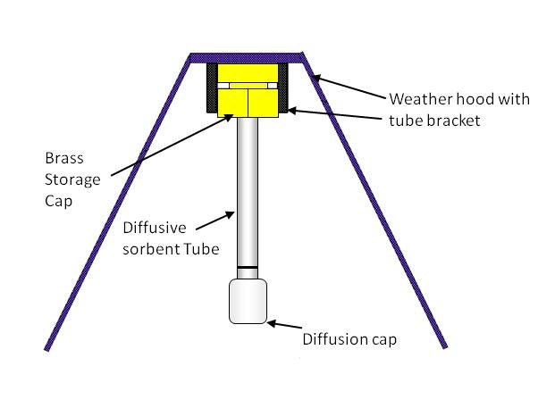

Figure 6.1. PS Tube with Weather Protector

  - Thermal Desorption Apparatus. If the analytical

thermal desorber that will subsequently be used to analyze the passive sampling tubes does not meet the requirement to exclude outer surface contaminants from the sample flow path (see Section 6.6 of Method 325B), then clean, white, cotton or
powder-free nitrile gloves must be used for handling the passive sampling tubes during field deployment.
  - Sorbent Selection. Sorbent tube configurations,

sorbents or other VOC not listed in this method must be evaluated according to Method 325B, Addendum A or ISO 16017- 2:2003(E) (Reference 13) (incorporated by reference—see §63.14). The supporting evaluation and verification data described in Method 325B, Addendum A for configurations or compounds different from the ones described in this method must meet the performance requirements of Method 325A/B and must be submitted with the test plan for your measurement program.
7.0 Reagents and Standards

No reagents or standards are needed for the field deployment and collection of passive sampling tubes.
Specifications for sorbents, gas and liquid phase standards, preloaded standard tubes, and carrier gases are covered in Section 7 of Method 325B.
  - Sample Deployment, Recovery, and Storage

Pre-deployment and planning steps are required before field deployment of passive sampling tubes. These activities include but are not limited to conducting a site visit, determining suitable and required monitoring locations, and determining the monitoring frequency to be used.
  - Conducting the Site Visit.

    - Determine the size and shape of the facility footprint in order to determine the required number of monitoring locations.
    - Identify obstacles or obstructions (buildings, roads, fences), hills and other terrain issues (e.g., bodies of
water or swamp land) that could interfere with air parcel flow to the sampler or that prevent reasonable access to the location. You may use the general guidance in Section 4.1 of this method during the site visit to identify sampling locations. You must evaluate the placement of each passive sampler to determine if the conditions in this section are met.
    - Identify to the extent possible and record potential off-site source interferences (e.g., neighboring industrial
facilities, transportation facilities, fueling operations, combustion sources, short-term transient sources, residential sources, nearby highways).
    - Identify the closest available meteorological station. Identify potential locations for one or more on-site or

near-site meteorological station(s) following the guidance in EPA-454/B-08-002 (Reference 11) (incorporated by reference—see
§63.14).

  - Determining Sampling Locations (References 2, 3).

    - The number and placement of the passive samplers depends on the size, the shape of the facility footprint or the linear distance around the facility, and the proximity of emission sources near the property boundaries. Aerial photographs or site maps may be used to determine the size (acreage) and shape of the facility or the length of the monitoring perimeter. Place passive samplers on an internal monitoring perimeter on or inside the facility boundary encompassing all emission sources at the facility at different angles circling the geometric center of the facility or at different distances based on the monitoring perimeter length of the facility.
Note: In some instances, permanent air monitoring stations may already be located in close proximity to the facility. These stations may be operated and maintained by the site, or local or state regulatory agencies. If access to the station is possible, a PS may be deployed adjacent to other air monitoring instrumentation. A comparison of the pollutant concentrations measured with the PS to concentrations measured by site instrumentation may be used as an optional data quality

indicator to assess the accuracy of PS results.

      - The monitoring perimeter may be located between the property boundary and any potential emission source near the property boundary, as long as the distance from the source to the monitoring perimeter is at least 50 meters (162 feet). If a potential emissions source is within 50 meters (162 feet) of the property boundary, the property boundary shall be used as the monitoring perimeter near that source.
      - Samplers need only be placed around the monitoring perimeter and not along internal roads or other right of ways that may bisect the facility.
      - Extra samplers must be placed near known sources of VOCs if the potential emission source is within 50 meters (162 feet) of the boundary and the source location is between two monitors. Measure the distance (x) between the two monitors and place another monitor halfway between (x/2) the two monitors. For example, in Figure 8.1, the facility added three additional monitors (i.e., light shaded sampler locations) and
in Figure 8.2, the facility added two additional monitors to provide sufficient coverage of all area sources.

Refinery (20% Angle)
Additional monitors
Note: Shaded sources are within 50 meters of the property boundary and are located between two monitors. Additional coverage required by this method was accomplished by placing the monitors halfway between two existing monitors.

Figure 8.1. Facility with a Regular Shape Between 750 and 1,500 Acres in Area

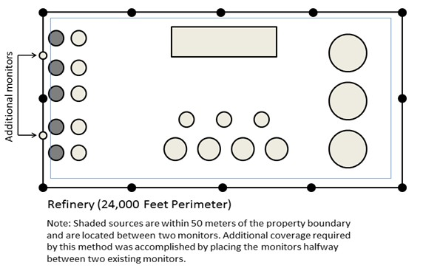

Figure 8.2. Facility with a Boundary Length of 24,000 feet

    - Option 1 for Determining Sampling Locations.

      - For facilities with a regular (circular, triangular, rectangular, or square) shape, determine the geographic center of the facility.
        - For facilities with an area of less than or equal to 750 acres, measure angles of 30 degrees from the center point for a total of twelve 30 degree measurements evenly spaced (±1 degree).
        - For facilities covering an area greater than 750 acres but less than or equal to 1,500 acres, measure angles of
20 degrees from the center point for a total of eighteen 20 degree measurements evenly spaced (±1 degree). Figure 8.1 shows the monitor placement around the property boundary of a facility with an area between 750 and 1,500 acres. Monitor placements are represented with black dots along the property boundary.
        - For facilities covering an area greater than 1,500 acres, measure angles of 15 degrees from the center point for a total of twenty-four 15 degree measurements evenly spaced (±1 degree).
        - Locate each sampling point where the measured angle intersects the outer monitoring perimeter.
      - For irregularly shaped facilities, divide the area into a set of connecting subarea circles, triangles or rectangles to determine sampling locations. The subareas must be

defined such that a circle can reasonably encompass the subarea. Then determine the geometric center point of each of the subareas.
        - If a subarea is less than or equal to 750 acres (e.g., Figure 8.3), measure angles of 30 degrees from the center
point for a total of twelve 30 degree measurements (±1 degree).

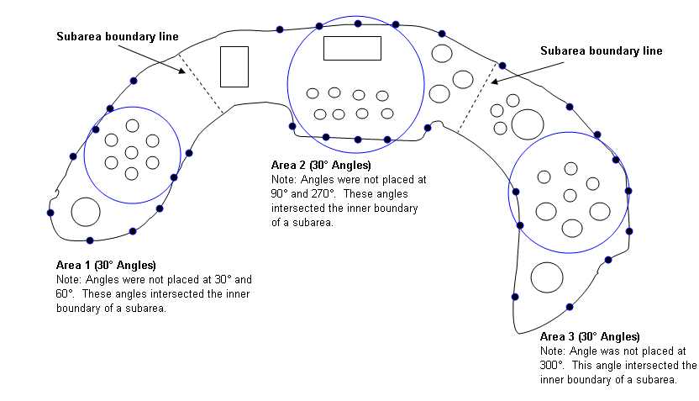

Figure 8.3. Facility Divided into Three Subareas

        - If a subarea is greater than 750 acres but less than or equal to 1,500 acres (e.g., Figure 8.4), measure angles
of 20 degrees from the center point for a total of eighteen 20 degree measurements (±1 degree).
        - If a subarea is greater than 1,500 acres, measure angles of 15 degrees from the center for a total of twenty-four
15 degree measurements (±1 degree).

        - Locate each sampling point where the measured angle intersects the outer monitoring perimeter. Sampling points need not be placed closer than 152 meters (500 feet) apart (or
76 meters (250 feet) if known sources are within 50 meters (162 feet) of the monitoring perimeter), as long as a minimum of 3 monitoring locations are used for each subarea.
        - Sampling sites are not needed at the intersection of an inner boundary with an adjacent subarea. The sampling location must be sited where the measured angle intersects the subarea’s outer monitoring perimeter.
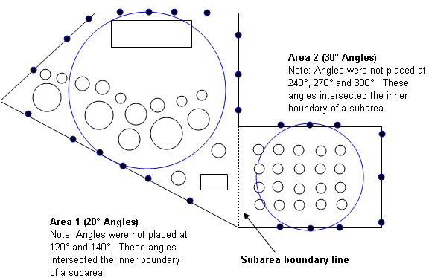

Figure 8.4. Facility Divided into Two Subareas

    - Option 2 for Determining Sampling Locations.

      - For facilities with a monitoring perimeter length

of less than 7,315 meters (24,000 feet), a minimum of twelve sampling locations evenly spaced  10 percent of the location interval is required.
      - For facilities with a monitoring perimeter length greater than 7,315 meters (24,000 feet), sampling locations are spaced 610 ± 76 meters (2,000  250 feet) apart.
  - Siting a Meteorological Station. A meteorological

station is required at or near the facility you are monitoring. A number of commercially available meteorological stations can be used. Information on meteorological instruments can be found in EPA-454/R-99-005 (Reference 11) (incorporated by reference— see §63.14). Some important considerations for siting of meteorological stations are detailed below.
    - Place meteorological stations in locations that represent conditions affecting the transport and dispersion of pollutants in the area of interest. Complex terrain may require the use of more than one meteorological station.
    - Deploy wind instruments over level, open terrain at a height of 10 meters (33 feet). If possible, locate wind instruments at a distance away from nearby structures that is equal to at least 10 times the height of the structure.
    - Protect meteorological instruments from thermal radiation and adequately ventilate them using aspirated shields. The temperature sensor must be located at a distance away from

any nearby structures that is equal to at least four times the height of the structure. Temperature sensors must be located at least 30 meters (98 feet) from large paved areas.
    - Collect and record meteorological data, including wind speed, wind direction, temperature and barometric pressure on an hourly basis. Calculate average unit vector wind direction, sigma theta, temperature and barometric pressure per sampling period to enable calculation of concentrations at standard conditions. Supply this information to the laboratory.
    - Identify and record the location of the meteorological station by its GPS coordinate.
  - Monitoring Frequency.

    - Sample collection may be performed for periods up to

14 days.

    - A site screening protocol that meets method requirements may be performed by collecting samples for a year where each PS accumulates VOC for a 14-day sampling period. Study results are accumulated for the sampling periods (typically 26) over the course of one calendar year. To the extent practical, sampling tubes should be changed at approximately the same time of day at each of the monitoring sites.
  - Passive Sampler Deployment.

    - Clean (conditioned) sorbent tubes must be prepared

and packaged by the laboratory as described in Method 325B and must be deployed for sampling within 30 days of conditioning.
    - Allow the tubes to equilibrate with ambient temperature (approximately 30 minutes to 1 hour) at the monitoring location before removing them from their storage/shipping container for sample collection.
    - If there is any risk that the analytical equipment will not meet the requirement to exclude contamination on outer tube surfaces from the sample flow path (see Section 6.6 of Method 325B), sample handlers must wear clean, white, cotton or powder-free nitrile gloves during PS deployment and collection and throughout any other tube handling operations.
    - Inspect the sampling tubes immediately prior to deployment. Ensure that they are intact, securely capped, and in good condition. Any suspect tubes (e.g., tubes that appear to
have leaked sorbent) should be removed from the sampling set.

    - Secure passive samplers so the bottom of the diffusive sampling cap is 1.5 to 3 meters (4.9 to 9.8 feet) above ground using a pole or other secure structure at each sampling location. Orient the PS vertically and with the sampling end pointing downward to avoid ingress of particulates.
Note: Duplicate sampling assemblies must be deployed in at least one monitoring location for every 10 monitoring locations during each field monitoring period.

    - Protect the PS from rain and excessive wind velocity by placing them under the type of protective hood described in Section 6.1.3 or equivalent.
    - Remove the storage cap on the sampling end of the tube and replace it with a diffusive sampling cap at the start of the sampling period. Make sure the diffusion cap is properly seated and store the removed storage caps in the empty tube shipping container.
    - Record the start time and location details for each sampler on the field sample data sheet (see example in Section 17.0.).
    - Expose the sampling tubes for the required sampling period-normally 14-days.
    - Field blank tubes (see Section 9.3 of Method 325B) are stored outside the shipping container at representative sampling locations around the site, but with both long-term storage caps kept in place throughout the monitoring exercise. Collect at least two field blanks sorbent samples per sampling period to ensure sample integrity associated with shipment, collection, and storage.
  - Sorbent Tube Recovery and Meteorological Data

Collection. Recover deployed sampling tubes and field blanks as

follows:

    - After the sampling period is complete, immediately

replace the diffusion end cap on each sampled tube with a long- term storage end cap. Tighten the seal securely by hand and then tighten an additional quarter turn with an appropriate tool.
Record the stop date and time and any additional relevant information on the sample data sheet.
    - Place the sampled tubes, together with the field blanks, in the storage/shipping container. Label the storage container, but do not use paints, markers, or adhesive labels to identify the tubes. TD-compatible electronic (radio frequency identification (RFID)) tube labels are available commercially and are compatible with some brands of thermal desorber. If used, these may be programmed with relevant tube and sample information, which can be read and automatically transcribed into the sequence report by the TD system.
Note: Sampled tubes must not be placed in the same shipping container as clean conditioned sampling tubes.
    - Sampled tubes may be shipped at ambient temperature to a laboratory for sample analysis.
    - Specify whether the tubes are field blanks or were used for sampling and document relevant information for each tube using a Chain of Custody form (see example in Section 17.0) that accompanies the samples from preparation of the tubes through receipt for analysis, including the following information: Unique tube identification numbers for each sampled

tube; the date, time, and location code for each PS placement; the date, time, and location code for each PS recovery; the GPS reference for each sampling location; the unique identification number of the duplicate sample (if applicable); and problems or anomalies encountered.
    - If the sorbent tubes are supplied with electronic (e.g., RFID) tags, it is also possible to allocate a sample identifier to each PS tube. In this case, the recommended format for the identification number of each sampled tube is AA-BB-CC- DD-VOC, where:
AA = Sequence number of placement on route (01, 02, 03. . .) BB = Sampling location code (01, 02, 03 . . .)
CC = 14-day sample period number (01 to 26)

DD | = | Sample  = | code (SA = field blank) | sample, DU | = | duplicate, FB
VOC | = | 3-letter code for target compound(s) benzene or BTX for benzene, toluene, |  |  | (e.g., BNZ for and xylenes)

Note: Sampling start and end times/dates can also be logged using RFID tube tags.
  - Quality Control

  - Most quality control checks are carried out by the laboratory and associated requirements are in Section 9.0 of Method 325B, including requirements for laboratory blanks, field blanks, and duplicate samples.
  - Evaluate for potential outliers the laboratory results

for neighboring sampling tubes collected over the same time period. A potential outlier is a result for which one or more PS tube does not agree with the trend in results shown by neighboring PS tubes—particularly when data from those locations have been more consistent during previous sampling periods.
Accidental contamination by the sample handler must be documented before any result can be eliminated as an outlier. Rare but possible examples of contamination include loose or missing storage caps or contaminated storage/shipping containers. Review data from the same and neighboring monitoring locations for the subsequent sampling periods. If the anomalous result is not repeated for that monitoring location, the episode can be ascribed to transient contamination and the data in question must be flagged for potential elimination from the dataset.
  - Duplicates and Field Blanks.

    - Collect at least one co-located/duplicate sample for every 10 field samples to determine precision of the measurements.
    - Collect at least two field blanks sorbent samples per sampling period to ensure sample integrity associated with shipment, collection, and storage. You must use the entire sampling apparatus for field blanks including unopened sorbent tubes mounted in protective sampling hoods. The tube closures

must not be removed. Field blanks must be placed in two different quadrants (e.g., 90° and 270°) and remain at the
sampling location for the sampling period. 10.0 Calibration and Standardization
Follow the calibration and standardization procedures for meteorological measurements in EPA-454/B-08-002 March 2008 (Reference 11) (incorporated by reference—see §63.14). Refer to Method 325B for calibration and standardization procedures for analysis of the passive sampling tubes.
11.0 Analytical Procedures

Refer to Method 325B, which provides details for the preparation and analysis of sampled passive monitoring tubes (preparation of sampling tubes, shipment and storage of exposed sampling tubes, and analysis of sampling tubes).
  - Data Analysis, Calculations and Documentation

  - Calculate Annual Average Fenceline Concentration.

After a year’s worth of sampling at the facility fenceline (for example, 26 14-day samples), the average (PSi) may be calculated for any specified period at each PS location using Equation

12.1.

PSi

 PSip
N

Eq. 12.1

Where:

PSi = Annual average for location i.

PSip = Sampling period specific concentration from Method 325B. i = Location of passive sampler (0 to 360°).
p = The sampling period.

N = The number of sampling periods in the year (e.g., for 14- day sampling periods, from 1 to 26).

Note: PSip is a function of sampling location-specific factors such as the contribution from facility sources, unusual localized meteorological conditions, contribution from nearby interfering sources, the background caused by integrated far- field sources and measurement error due to deployment, handling, siting, or analytical errors.
  - Identify Sampling Locations of Interest. If data from

neighboring sampling locations are significantly different, then you may add extra sampling points to isolate background contributions or identify facility-specific “hot spots.”
  - Evaluate Trends. You may evaluate trends and patterns

in the PS data over multiple sampling periods to determine if elevated concentrations of target compounds are due to operations on the facility or if contributions from background sources are significant.
    - Obtain meteorological data including wind speed and wind direction or unit vector wind data from the on-site meteorological station. Use this meteorological data to determine the prevailing wind direction and speed during the periods of elevated concentrations.

    - As an option you may perform preliminary back trajectory calculations (http://ready.arl.noaa.gov/HYSPLIT.php)
to aid in identifying the source of the background contribution to elevated target compound concentrations.
    - Information on published or documented events on- and off-site may also be included in the associated sampling period report to explain elevated concentrations if relevant. For example, you would describe if there was a chemical spill on site, or an accident on an adjacent road.
    - Additional monitoring for shorter periods (See section 8.4) may be necessary to allow better discrimination/resolution of contributing emission sources if the measured trends and associated meteorology do not provide a clear assessment of facility contribution to the measured fenceline concentration.
    - Additional records necessary to calculate sampling period average target compound concentration can be found in Section 12.1 of Method 325B.
13.0 Method Performance

Method performance requirements are described in Method

325B.

14.0 Pollution Prevention

[Reserved]

  - Waste Management

[Reserved] 16.0 References
    - Ambient air quality- Standard method for measurement of benzene concentrations – Part 4: Diffusive sampling followed by thermal desorption and gas chromatography, BS EN 14662- 4:2005.
    - Thoma, E.D., Miller, C.M., Chung, K.C., Parsons, N.L. and Shine, B.C. Facility Fence Line Monitoring using Passive Samplers, J. Air & Waste Mange. Assoc. 2011, 61:834-842.
    - Quality Assurance Handbook for Air Pollution Measurement Systems, Volume II: Ambient Air Quality Monitoring Program, EPA-454/B-13-003, May 2013. Available at http://www.epa.gov/ttnamti1/files/ambient/pm25/qa/QA-Handbook- Vol-II.pdf
    - Brown, R.H., Charlton, J. and Saunders, K.J.: The development of an improved diffusive sampler. Am. Ind. Hyg. Assoc. J. 1981, 42(12): 865-869.
    - Brown, R. H. Environmental use of diffusive samplers: evaluation of reliable diffusive uptake rates for benzene, toluene and xylene. J. Environ. Monit. 1999, 1 (1), 115-116.
    - Ballach, J.; Greuter, B.; Schultz, E.; Jaeschke, W. Variations of uptake rates in benzene diffusive sampling as a function of ambient conditions. Sci. Total Environ. 1999, 244, 203-217.

    - Brown, R. H. Monitoring the ambient environment with diffusive samplers: theory and practical considerations. J Environ. Monit. 2000, 2 (1), 1-9.
    - Buzica, D.; Gerboles, M.; Plaisance, H. The equivalence of diffusive samplers to reference methods for monitoring O3, benzene and NO2 in ambient air. J. Environ. Monit. 2008, 10 (9), 1052-1059.
    - Woolfenden, E. Sorbent-based sampling methods for volatile and semi-volatile organic compounds in air. Part 2. Sorbent selection and other aspects of optimizing air monitoring methods. J. Chromatogr. A 2010, 1217, (16), 2685-94.
    - Pfeffer, H. U.; Breuer, L. BTX measurements with diffusive samplers in the vicinity of a cokery: Comparison between ORSA-type samplers and pumped sampling. J. Environ. Monit. 2000, 2 (5), 483-486.
    - US EPA. 2000. Meteorological Monitoring Guidance for Regulatory Modeling Applications. EPA-454/R-99-005. Office of Air Quality Planning and Standards, Research Triangle Park, NC. February 2000. Available at http://www.epa.gov/scram001/guidance/met/mmgrma.pdf.
    - Quality Assurance Handbook for Air Pollution Measurement Systems. Volume IV: Meteorological Measurements Version 2.0 Final, EPA-454/B-08-002 March 2008. Available at http://www.epa.gov/ttnamti1/files/ambient/met/Volume%20IV_Meteor

ological_Measurements.pdf.

    - ISO 16017-2:2003(E), Indoor, ambient and workplace air

- Sampling and analysis of volatile organic compounds by sorbent tube/thermal desorption/capillary gas chromatography. Part 2: Diffusive sampling.
    - ASTM D6196-03 (Reapproved 2009): Standard practice for selection of sorbents, sampling, and thermal desorption analysis procedures for volatile organic compounds in air.
17.0 Tables, Diagrams, Flowcharts and Validation Data

Method 325 A/B

EXAMPLE FIELD TEST DATA SHEET (FTDS) AND
CHAIN OF CUSTODY

- GENERAL INFORMATION

SITE NAME:

SITE LOCATION ADDRESS:

CITY: STATE: ZIP:

SAMPLING DATA

Sample ID  (Tube) |  | Sample or | Start | Start | Stop | Stop | Location | Ambient Temp. | Barometric Pressure
# | Sorbent | blank | Date | Time | Date | Time | (gps) | (F) | (in. Hg)

- CUSTODY INFORMATION

COLLECTED BY:
Relinquished to Shipper -

Name: Received by Laboratory - Name
Date:

Date:
Time

Time

Sample condition upon receipt:

Analysis Required:

Comments:

Figure 17.1. Example Field Data Form and Chain of Custody

